 

**Solar**

**System**

**Quotation**

**To**

Mr./Ms **{name}**

**{phone}**

**{email}**

**{project_location}**

**{quote_date}**

**From**

**M/s. Arpit Solar Shop**

Authorized Channel Partner: **Reliance New Energy**

Office: Sh16/114-25-K-2, Sharvodayanagar, Kadipur, Shivpur, Varanasi 221003(UP)

Branches: Ballia | Gorakhpur

Contact: 9005770466

WA Chatbot: 9044555572

Email: [info@arpitsolar.com](mailto:info@arpitsolar.com)

Web: [www.arpitsolar.com](http://www.arpitsolar.com/)

Gstin: 09APKPM6299L1ZW

# **Quotation for {product_category} Residential HJT Solar System {power_demand_kw} KW.**

# 

|  |  |  |
| --- | --- | --- |
| **Sr. No.** | **Description** | **Quantity** |
| 1 | System Size | **{power_demand_kw}** |
| **2** | 690 Wp HJT NDCR Solar Modules | **{number_of_modules}** |
| 3 | Inverter Capacity (kW) | **{inverter_capacity}** |
| 4 | Price/Watt (₹) | **{price_per_watt}** |
| 5 | Phase | **{phase}** |
| 6 | **Total Amount (₹)**  ***(Exclusive of GST)*** | **{hdg_elevated_price}** |

# **Disclaimer:** Prices are subject to change. Final price will be confirmed at the time of purchase.

**Know Your Product:**

HJT (Heterojunction) Solar Panels combine crystalline silicon and thin-film technology for unmatched efficiency. Their bifacial design captures sunlight from both sides, delivering higher energy yield even in low-light conditions. Built to last, they offer minimal degradation and reliable performance for over 25 years.

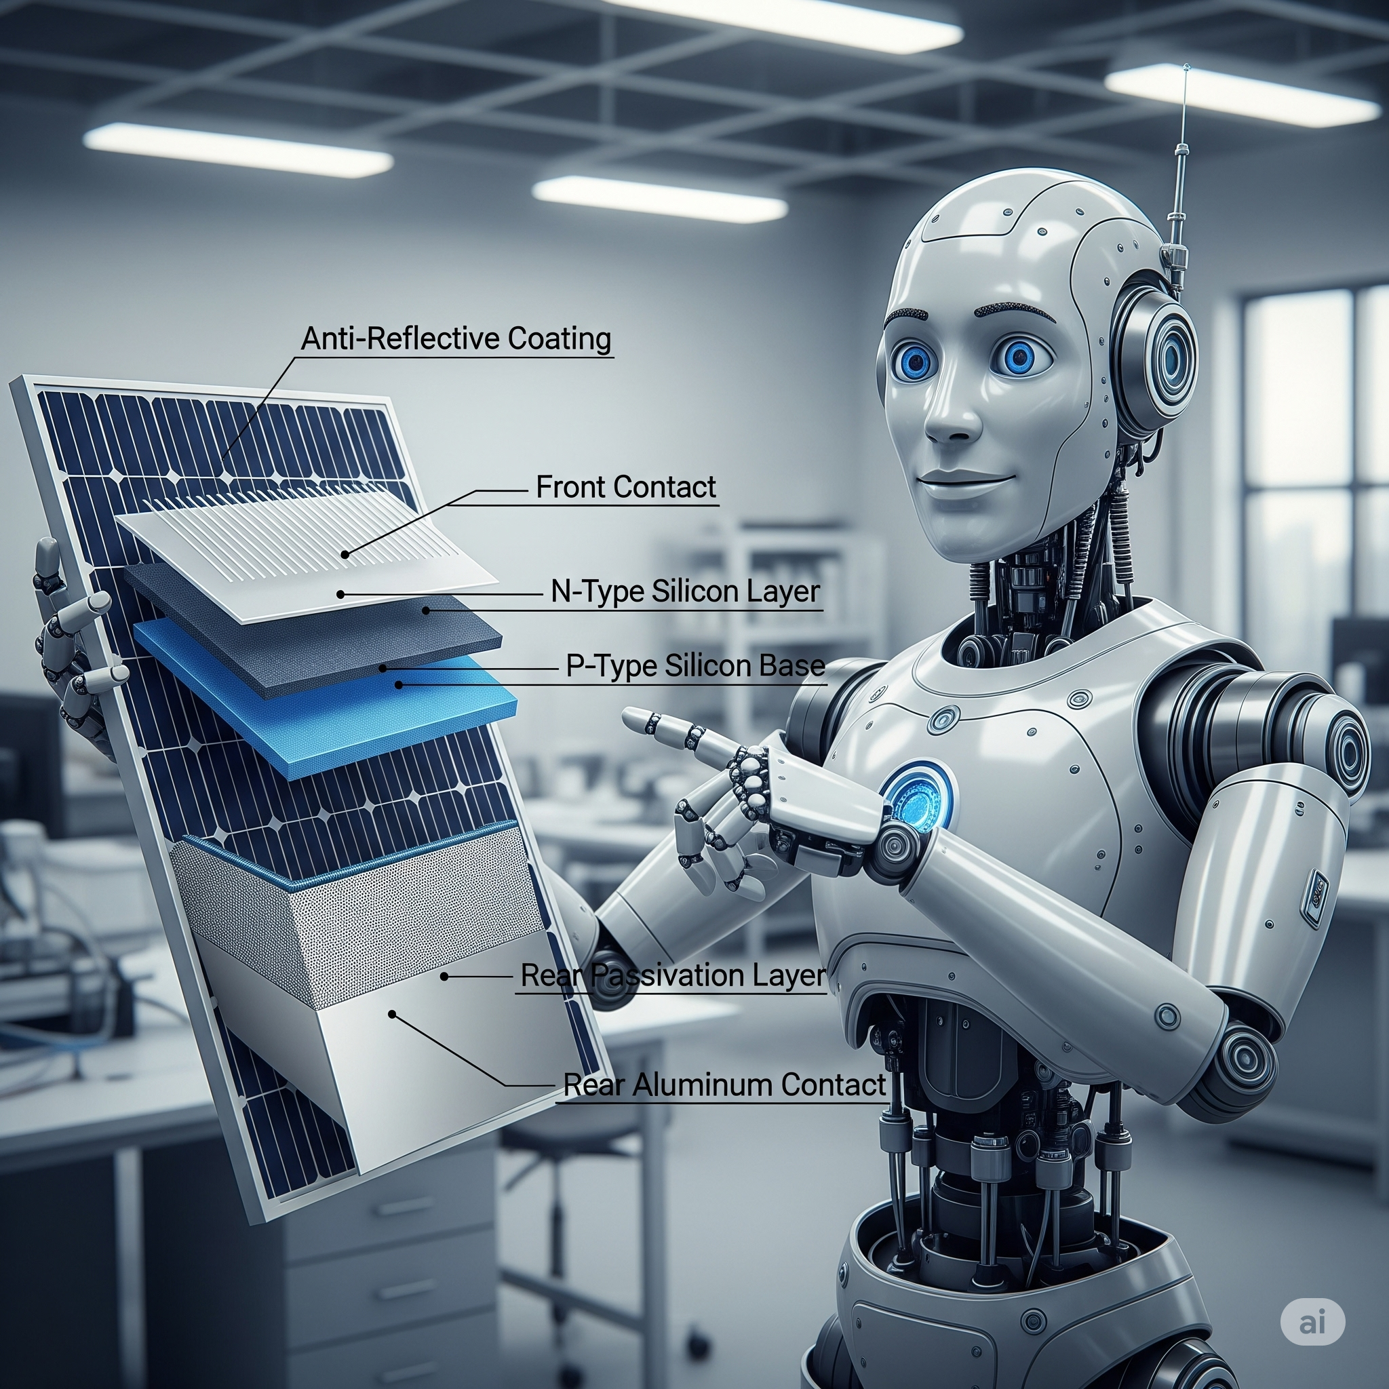

**High Efficiency** – HJT (Heterojunction) Solar Panels combine crystalline silicon and thin-film technologies for superior performance, delivering exceptional efficiency and higher power output.

**Better Low-Light Performance** – With outstanding performance during mornings, evenings, and cloudy weather, these panels continue to produce more energy even in shaded conditions.

**Bifacial Design** – Captures sunlight from both the front and rear sides, boosting overall energy production and maximizing site potential.

**Lower Temperature Coefficient** – Maintains high output even in extreme heat, ensuring stable performance in hot climates like India.

**Longer Lifespan** – Minimal power degradation over time ensures decades of reliable operation, with performance warranties often exceeding 25 years up to 30 years.

**Environment-Friendly** – Manufactured using low carbon footprint processes, making them a greener choice for sustainable energy production.